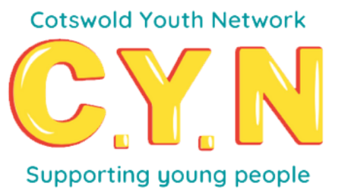
Cotswold Youth Network Small Grants
The Cotswold Youth Network has nearly £20000 to allocate this year for youth led ideas which will lead to a positive difference in your community.
Guidance notes for applicants
How much can you apply for?
- Grants of up to £1000 per group (a larger project in exceptional circumstances may be considered but please contact us first to discuss)
Who can apply?
- Young people involved in a group with the support of an adult
- Those with an idea that leads to a positive difference in their community
- Those with an idea that kick starts or enhances community-based activities, e.g. setting up a new club, putting on an event, start-up costs for a new business or social enterprise
Grant applications must meet at least one of these criteria:

- Provide opportunities to improve community facilities and the environment
- Support projects with a health/well-being focus
- Contribute to diverse and inclusive communities
- Support volunteers and volunteering opportunities
- Support arts and cultural related activities
- Support a range of sport and physical activities
- Support access to training, employment and further opportunities
We will not fund:
- Purchases prior to funding being confirmed
- Activities and Services that promote political or religious beliefs
- On-going core costs e.g. staff
- Activities where funding has already been secured
- Payments to individuals or privately owned business
- Organisations with aims that do not match those of the CYN
- Anything that discriminates against individuals or organisations
- Anything that promotes any illegal or immoral purposes

How to apply
Complete the following application form and return to jane@worldjungle.org.uk
We will contact you to discuss your application and if successful will request bank details of your organisation.
How we will assess your application
A panel of people involved in local community and charity groups will assess applications based on the criteria stated above.

Promotion and PR
If successful, we will keep in touch with you and hope to share your project through our social media channels. We will obtain permission for this if you are successful with your application.

Data Protection
We will collect, store, use, amend, share, destroy or delete personal data only in ways which protect people’s privacy and comply with the UK General Data Protection Regulation (GDPR) and other relevant legislation.

Cotswold Youth Network Small Grants Application Form
Name of project
Name of supporting organisation
Main contact (young person) | Name
 | Telephone
 | email
Main contact (adult support) | Name
 | Telephone
 | email
Location of project
Project idea
Give a brief description, explain what you intend to do and why you are doing it.
Please continue on the back if more space needed.

Tell us about the young people developing this project (how many are involved, what ages, male /female and anything else you feel is relevant

How will it support the community?
Budget
How much money do you need and what will it be spent on?
Please attach a spreadsheet if necessary.
Signature of young person |  |  | Date
Signature of supporting adult |  |  | Date

